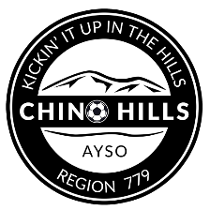 | Chino Hills AYS0 – REGION 779  2023 KICKIN’ IT UP IN THE HILLS CLASSIC  TOURNAMENT GUEST PLAYER FORM | 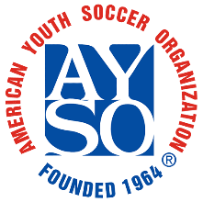

Borrowing Team Information: |  |  |  |  |  |  |  |  | Roster Date:
Region: |  |  |  |  |  | Team Name:

Coach Name:
Age Division: |  |  | U-10 |  |  |  | U-12 |  |  | U-14 |  |  | U-16 |  |  | U-19 |  | Boys |  |  |  | Girls |  | Coed

2023 KICKIN’ IT UP IN THE HILLS CLASSIC rules allow teams to bring up to 3 “Guest Players” when they are unable to recruit sufficient players from their own region. These Guest Players must be properly registered AYSO players who were registered and played 50% of their home region games for the 2022 primary season.

(List In Order By Uniform Shirt No.)
Shirt  # | Region  # | Player ID # | Player’s Name  Last, first (please print) | Age | Date of Birth | Telephone  Including Area Code
By my signature below, I certify that all players on this roster are valid registered players in my region and are approved to join the above team and participate in this tournament:
Guest Player(s) Regional Commissioner:
 |  | Print Name Signature (Blue or Red Ink)
Email: |  |  |  | Best Phone:
By my signature below, I approve that these |  |  |  |  | (number of players) guest players are
approved to join the above team and participate in this tournament:

Host Team Regional Commissioner:

